**MOBILITY AID DEVICE FOR WHEELCHAIR USERS TO BE USED IN A RAILWAY SYSTEM**

*Report submitted to the SASTRA Deemed to be University*

*as the requirement for the course*

**MCT300 MINI PROJECT**

*Submitted by*

**AMBHAREESH M D**

**(Reg.No.123012008)**

**VENKATRAMAN S**

**(Reg.No.123012046)**

**SETHU NARAYANAN S**

**(Reg.No.123012057)**

**June 2022**



**SCHOOL OF MECHANICAL ENGINEERING**

**THANJAVUR, TAMIL NADU, INDIA – 613 401**



**SCHOOL OF MECHANICAL ENGINEERING**

**THANJAVUR, TAMIL NADU, INDIA – 613 401**

**Bonafide Certificate**

This is to certify that the report titled “**Mobility Aid Device for wheelchair users to be used in a Railway system**” submitted as a requirement for the course, **MCT 300 Mini-project** for B.Tech. Mechatronics programme, is a bonafide record of the work done by

**Mr. Ambhareesh M D (Reg.No: 123012008)**

**Mr. Venkatraman S (Reg.No: 123012046)**

**Mr. Sethu Narayanan S (Reg.No: 123012047)**

during the academic year 2021-22, in the School of Mechanical Engineering, under my supervision.

**Signature of Project Supervisor :**

**Name with Affiliation : Dr. R.Hari Krishnan, Assistant Professor-Research**

**Date : 26-06-2022**

Mini-project Viva-voce held on **28-06-2022**





**SCHOOL OF MECHANICAL ENGINEERING**

**THANJAVUR, TAMIL NADU, INDIA – 613 401**

**Declaration**

We declare that the report titled “**Mobility Aid Device for wheelchair users to be used in a Railway system**” submitted by us is an original work done by us under the guidance of **Dr. R.Hari Krishnan, School of Mechanical Engineering, SASTRA Deemed to be University** during the even semester of the academic year 2021-22, in the **School of Mechanical Engineering**. The work is original and wherever we have used materials from other sources, we have given due credit and cited them in the text of the report. This report has not formed the basis for the award of any degree, diploma, associateship, fellowship or other similar title to any candidate of any University.

**Signature of the candidate(s) :** 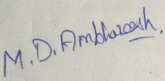 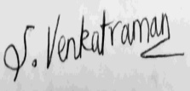  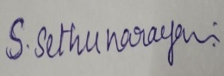

**Name of the candidate(s) : Ambhareesh M D, Venkatraman S, Sethu**

**Narayanan S**

**Date :**

**Acknowledgement**

On the very first of this report, we would like to extend our sincere thanks to all the people who have helped us with this project. Without their active guidance, help, cooperation, and support, we would not have made advancements in the project.

It is my sincere duty to express a deep sense of gratitude to our honorable Vice Chancellor Dr. **S.Vaidhyasubramaniam, SASTRA Deemed to be University** the paramount of the institution, and for his patronage.

I express my sincere thanks and gratitude to **Dr. S.Pugazhenthi, Dean, School of Mechanical Engineering, SASTRA Deemed to be University**, for his support in the accomplishment of this project work.

Foremost, we would like to express our sincere gratitude to our project guide, **Dr. R.Hari Krishnan**, for the continuous support of our project work, and for his patience, motivation, enthusiasm, and immense knowledge.

We extend our gratitude to SASTRA Deemed to be University for giving us this opportunity in developing the project and people who have helped us out with their abilities.

We acknowledge with a deep sense of report, and gratitude towards our parents and our family members, who have always supported us morally. Last but not least, we thank our friends who have directly or indirectly helped us in this project work.

**List of Figures**

|  |  |  |
| --- | --- | --- |
| **Figure No** | **Title** | **Page No.** |
| 4.1 | Flowchart of our Methodology | 6 |
| 4.2 | Open loop control system for speed control of a DC motor | 8 |
| 4.3 | (i) Torque-time specification  (ii) Speed-time specification  (iii) Position-time specification | 9 |
| 4.4 | Closed loop speed control of a PMDC motor | 10 |
| 4.5 | PID tuning using internal app | 11 |
| 4.6 | Comparison between tuned and untuned responses of the model | 12 |
| 4.7 | Closed loop control system for linear actuator | 13 |
| 4.8 | speed controller subsystem | 13 |
| 4.9 | current controller subsystem | 14 |
| 4.10 | Tracking error Vs Frequency | 15 |
| 4.11 | Untuned response of the model | 16 |
| 4.12 | Tuned response of the model | 16 |
| 4.13 | Wheelchair design | 18 |
| 4.14 | Telescope mechanism in extended position | 18 |
| 4.15 | Telescope mechanism in retracted position | 18 |
| 4.16 | Entraining and detraining mechanism | 19 |
| 5.1 | Simulation result of closed loop control of Motor drive | 20 |
| 5.2 | Simulation result from closed loop control of linear actuator | 21 |
| 5.3. | Failed Attempts | 21 |

**List of Tables**

|  |  |  |
| --- | --- | --- |
| **Table No.** | **Table Name** | **Page No.** |
| 4.1 | Motor specification | 9 |
| 4.2 | Tuning requirements | 15 |
| 4.3 | PI value for 50kg load | 17 |
| 4.4 | PI value for 100kg load | 17 |
| 4.5 | PI value for 1500kg load | 17 |

**ABBREVATIONS**

PI controller– Proportional Integral controller

PID controller– Proportional Integral Differential controller

PwD - Person with Disabilities

H-Henry

RPM-Revolutions per minute

URDF – Unified Robotics Description Format

.STL- Standard Lithography

Ω - Ohm

*i* – Armature current

*J* – Motor Inertia

*L* –armature inductance

*B* -damping factor

- back emf constant

*kt* – torque constant

*R*- Armature Resistance

**ABSTRACT**

The world's population, which includes nearly 15% of those with disabilities. People with physical disabilities and elders generally find it difficult to board the vehicles, especially when it comes to entraining, detraining, and traversing within the train compartments and railway stations. Several mobility assistive devices like manual and powered wheelchairs, modified electric scooters, etc. are available for Persons with Disabled (PWD) to locomote in public places. One of the most widely utilized assistive technologies to enable mobility and improve the quality of life for the elderly and disabled is the wheelchair. But, there are no devices that enable them to board a train and traverse to their seat and also aid them in transferring from one surface to another. The self-transfer vehicle is used to transfer the people from one surface to another without any help from others. Our main work is to develop a simulation model of a complete locomotion system specifically designed to enable locomotion on the railway platform, entrain/detrain, and self-transfer whenever necessary. For this, we created and analyzed the model of the wheelchair along with the self-transfer vehicle attached to it. The wheelchair and self-transfer vehicle are designed in the SOLIDWORKS software and the environment for the railway station platform and train is simulated in CoppeliaSim software. The control system to control the speed of the motor for to and fro motion and up and down motion of the wheelchair is developed in the MATLAB software and it is integrated with the wheelchair using the simulation framework CoppeliaSim.

**Specific Contribution**

* I created and analyzed the model of the wheelchair along with the self-transfer vehicle attached to it.
* At last, I designed the wheelchair and self-transfer vehicle in the SOLIDWORKS software and it was converted into a URDF file and imported to the CoppeliaSim software.

**Specific Learning**

* Learned how to use SOLIDWORKS software.
* Learned how to use CoppeliaSim software.
* Learned about different blocks and the control systems in the Simulink software.

**-Ambhareesh M D**

**ABSTRACT**

People with physical disabilities and elders generally find it difficult to board the vehicles, especially when it comes to entraining, detraining and traversing within the train compartments and railway stations. Several mobility assistive devices like manual and powered wheelchairs, modified electric scooters etc. are available for Persons with Disabled (PWD) to locomote in public places. But, there are no devices that enable them to board a train and traverse to their seat and also aid them in transferring from one surface to another. The objective of this work is to develop a simulation model of a complete locomotion system specifically designed to enable locomotion in railway platform, entrain/detrain and self-transfer whenever necessary. The control system of the proposed device will be developed using MATLAB software and will be integrated with the developed model using the simulation framework CoppeliaSim.

**Specific Contribution**

* Designed the Open loop and Closed Loop Speed control system of the PMDC Motor used for Locomotion in MATLAB.
* Designed the Closed Loop Speed control system of Linear Actuator in MATLAB.
* Designed a Wheelchair with Step climbing ability in SOLIDWORKS software.
* Designed a Simple DYOR Vehicle using pure objects in CoppeliaSim software.
* Designed the Telescopic mechanism in SOLIDWORKS software

**Specific Learning**

* Learnt to work with Simulink and Simscape.
* Learnt to Design a Linear Control System using Control System Designer App and auto-tune the designed controller using the internal app of MATLAB software.
* Learnt to Import SOLIDWORKS files to CoppeliaSim software using mesh files. (without the use of URDF Convertor)
* Learnt about the importance of Joint-Link Hierarchy in CoppeliaSim software.
* Learnt to work with SOLIDWORKS (2021) software.
* Familiarized and Understood the Working environment of CoppeliaSim software and Lua Programming.

**- Venkatraman S**

**ABSTRACT**

Entraining and detraining from the train was the most challenge for the disabled. On the train platform, they encounter numerous problems as well. We focused primarily on creating a wheelchair for the elderly and crippled when solving this problem. These individuals must move from their wheelchair to a seat after boarding the train. Usually, other people assist them in moving from one location to another. However, we focused on transferring themselves, without assistance from others. To do this, we created a self-transfer vehicle that allows users to go from one location to another unaided. We developed and examined the wheelchair and a self-transfer vehicle attached to the wheelchair by taking into accounts all of these elements.

**SPECIFIC CONTRIBUTION:**

* I created and analyzed the model of an actuator to be attached with the wheels of the self-transfer vehicle
* Supported in creating actuator the model in SOLIDWORKS which is then imported to CoppeliaSim as a URDF file.
* Analyzed the stability of a wheel chair designed a castor ball and socket wheel to obtain proper stability.

**SPECIFIC LEARNING:**

* Learnt to use CoppeliaSim software.
* Learnt to design and extrude objects in SOLIDWORKS software.
* Learnt the importance of proper mating of objects.

-**Sethu Narayanan S**

**Table of Contents**

**Title Page No.**

Bona-fide Certificate ii

Declaration iii

Acknowledgements iv

List of Figures v

List of Tables vi

Nomenclature vii

Abstract viii

1. Introduction 1

1.1. Reported facts 1

1.2. Major Problem 1

1.3. Motivation 2

1.4. Problem Statement 2

1. Objectives 3

3. Literature Review 4

4. Implementation methodology 5

4.1. Motor drive speed control 6

4.1.1. Transfer function for speed control of a PMDC motor 6

4.1.2. Open loop control system for speed control of a DC motor 7

4.2. Closed loop speed control of a PMDC motor 9

4.3. Linear actuator control 11

4.3.1. Speed control sub system 12

4.3.2. Current control sub system 12

4.3.3. Tuning of the cascaded controllers 13

4.4. Design of step climbing wheelchair 15

4.5. Process 17

4.6. Mechanism 17

5. Result and discussion 18

5.1. Result 18

5.2. Discussion 19

6. References 20

7. Appendix 23

7.1 Similarity Check Report

**CHAPTER 1**

**INTRODUCTION**

**1.1. REPORTED FACTS:**

According to government studies, two-thirds of passengers with disabilities still encounter obstacles to travel when utilising trains. Respondents to the Department for Transport (DfT) survey mentioned a lack of accessible restrooms in carriages, difficulties using ticket machines, and antisocial conduct. 37 percent of individuals who reported issues with train travel cited confusing onboard announcements, and 29 percent of those polled stated they had been on a train without accessible restrooms. Another 31% of passengers with disabilities reported encountering rude or discriminatory conduct from other travelers, including hostile replies after requesting a priority seat. Many passengers with disabilities said they also had to meticulously plan their journeys because of problems like inaccessible stations and the lack of priority seating on trains. They said this included travelling at off-peak times, booking in advance, and making sure they left enough time to account for unplanned events like running into a broken lift. Although 20% of respondents claimed to have reserved passenger assistance in advance before taking a train, the service is not always available at stations, and its general availability was not well-known. The quantity of tangible tickets, including seat reservation slips, needed for a travel was one difficulty mentioned by several customers when they reported accessibility issues at stations[9].

**1.2. MAJOR PROBLEM:**

Entraining and detraining from the train was the most challenge for the disabled. On the train platform, they encounter numerous problems as well. We focused primarily on creating a wheelchair for the elderly and crippled when solving this problem. These individuals must move from their wheelchair to a seat after boarding the train. Usually, other people assist them in moving from one location to another. However, we focused on transferring themselves, without assistance from others. To do this, we created a self-transfer vehicle that allows users to go from one location to another unaided. We developed and examined the wheelchair and a self-transfer vehicle attached to the wheelchair by taking into accounts all of these elements.

**1.3. MOTIVATION:**

We are aware of numerous applications that are similar replicas or modifications of wheelchairs, whose characteristics are used to produce the same results. In order to give the user a pleasant transportation zone and to enable the vehicle to operate independently of additional help or guidance, we improvised some of the references we obtained using either technique. In contrast to previous developments, we also need a balanced architecture; for these reasons, we preferred the castor wheel and the construction of an entirely balanced structure.

**1.4. PROBLEM STATEMENT:**

Develop a simulation model of a complete locomotion system specifically designed to transverse to a railway platform, board it and transverse to the designated seat and enable self-transfer.

**CHAPTER 2**

**OBJECTIVE**

* Our ultimate purpose is to create a simulation model of a comprehensive locomotion system that is specifically made to allow people who are disabled or impaired to board a train, navigate to their allotted seat, and self-transfer.
* To enable a person with a physical disability of the lower or upper limbs to move about safely.
* To design and create a powered robotic self-transfer device that will be used in conjunction with a powered wheelchair as well as an automated self-transfer vehicle.
* To simulate the precise model that we had in consideration.
* To develop control systems in order to control the speed of the motor for locomotion and up and down motion of linear actuators in the wheelchair.

**CHAPTER 3**

**LITERATURE REVIEWS**

From the Environment adaptation of a new *staircase-climbing wheelchair* done *by R. Morales, A. Gonzalez, V. Feliu, P. Pintado* [5] we learned few points include

* The two decoupling mechanisms have been introduced and comprehended. a thorough understanding of how it operated. Up until it reaches step height, a rack is activated to lift the front wheel.
* Once weight is immediately transferred to the front wheels and the back wheels have climbed the stair, the wheels are then deployed backwards.
* Vertical stability is maintained by two serial kinematic chains connecting a parallel mechanism with the mobile platform to the base**.**

Also we studied a sample *Design of A Wheel-Legged Stair Climbing Robot***,** done by *Y. Ma* and *F. Lyu*[7]

* We studied and acquired a thorough understanding of the leg-based stair climbing wheelchair's control system.
* Additionally, we discovered how to arrange wheels, actuators, and sensors along a path. Simplify the seventeen actuators that are used for climbing up and down duties.
* The approach suggested in this paper makes the system resilient to sensor uncertainties and minor mechanical parameter mistakes, hence making the structure safer.
* The practical use of the kinematic control is facilitated by this control architecture.
* Additionally, this tactic can be used to optimize how the mechanism is configured.

We studied the importance of climbing effect and were concentrating on the stability of our device so we read a journal on *Control architecture for a novel Leg-Based Stair-Climbing Wheelchair* done by *D. Delgado-Mena, E. Pereira, C. Alén-Cordero, S. Maldonado-Bascón and P. Gil-Jiménez*[6]

* We learned about six linear actuator-equipped wheel-legged robots that can climb stairs and navigate obstacles.
* This design can handle uneven stairs with good operation stability due to its control algorithm.
* The climbing techniques for a single step and several stairs were established, and we produced our actual prototype.
* Also studied the experimental findings and discovered the mechanical design's viability and the efficiency of its climbing algorithms.

Finally we came to the point of self transfer and referred the journal Development of a *Mechanism to Dock a Robotic Self-Transfer Device to a Wheelchair* done *by N. Shashank Shivakumar, V. Shreyaas Viishvak, R. B. K. Ashok and R. Hari Krishnan*[8]

* We realize the mechanical self-transfer concept where the rotary transfer is facilitated by a turntable with an epicyclic gear train, while the rising is accomplished by lockable gas springs.
* Additionally, the system's general acceptance has been investigated.
* The findings indicate that the gadget can move a person more easily from a wheelchair to another surface**.**

**CHAPTER 4**

**IMPLEMENTATION METHODOLOGY**

Since our project involves simulation of complete locomotion of a wheelchair with step climbing ability and self-transfer mechanism, we decided to use MATLAB to design and test our Speed Control system and then integrate it with the 3D model in CoppeliaSim software.

The add-ons we used are:

* Simulink
* Control System Toolbox
* Simulink Control Design
* Simscape Electrical

The goals we set ourselves to realize the final outcome is as shown in Fig. 4.1:

Fig. 4.1 Flowchart of our Methodology

Detailed Explanation of our designed control system and the functioning of each sub-system are explained below. Mathematical modeling of PMDC motor is done based on Armature current control technique.

**4.1. MOTOR DRIVE SPEED CONTROL:**

**4.1.1 Transfer function for Speed control of a PMDC Motor**

(1.1)

(1.2)

(1.3)

(1.4)

Taking Laplace transform of the above equation

(1.5)

(1.6)

(1.7)

(1.8)

From (1.5)

From (1.8)

From (1.6)

(1.7) =>

(1.9)

Where *i* – armature current, *J* – Motor Inertia, *L* –armature inductance, *B* -damping factor, - back emf constant, *kt*– torque constant, *R*- armature Resistance

**4.1.2. Open loop control system for speed control of a DC motor**

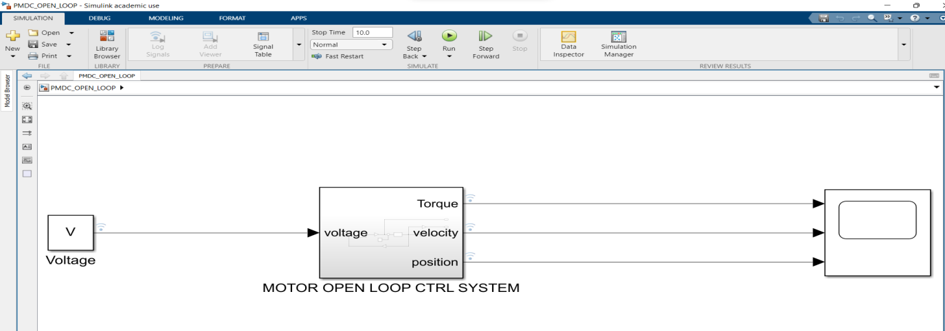

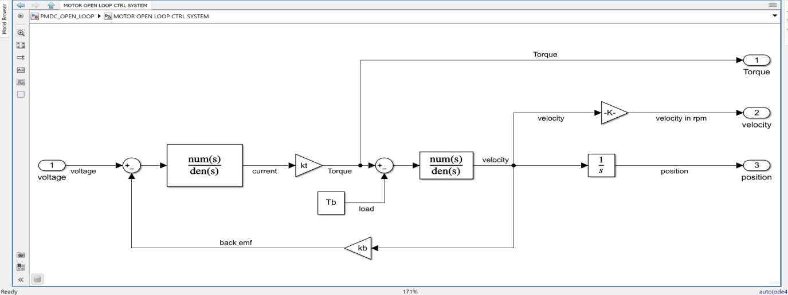Fig. 4.2 Open loop control system for speed control of a DC motor

The above Fig. 4.2 is the Open Loop Control system we developed in Simulink using the Open Loop Transfer function. The Simulink model has the following motor parameters as listed in the Table 4.1.

Table. 4.1 Motor specification

|  |  |  |
| --- | --- | --- |
| **S.No.** | **Motor Parameters** | **Values** |
| **1.** | Inertia | 5 kg.m2 |
| **2.** | Back emf constant | 1.6 |
| **3.** | Torque constant | 1.6 |
| **4.** | Armature Resistance | 0.5 Ω |
| **5.** | Load Torque | 20 Nm |
| **6.** | Armature Inductance | 0.1 H |

The entire Simulink flow is converted into a subsystem leaving the input reference speed and the Scope.

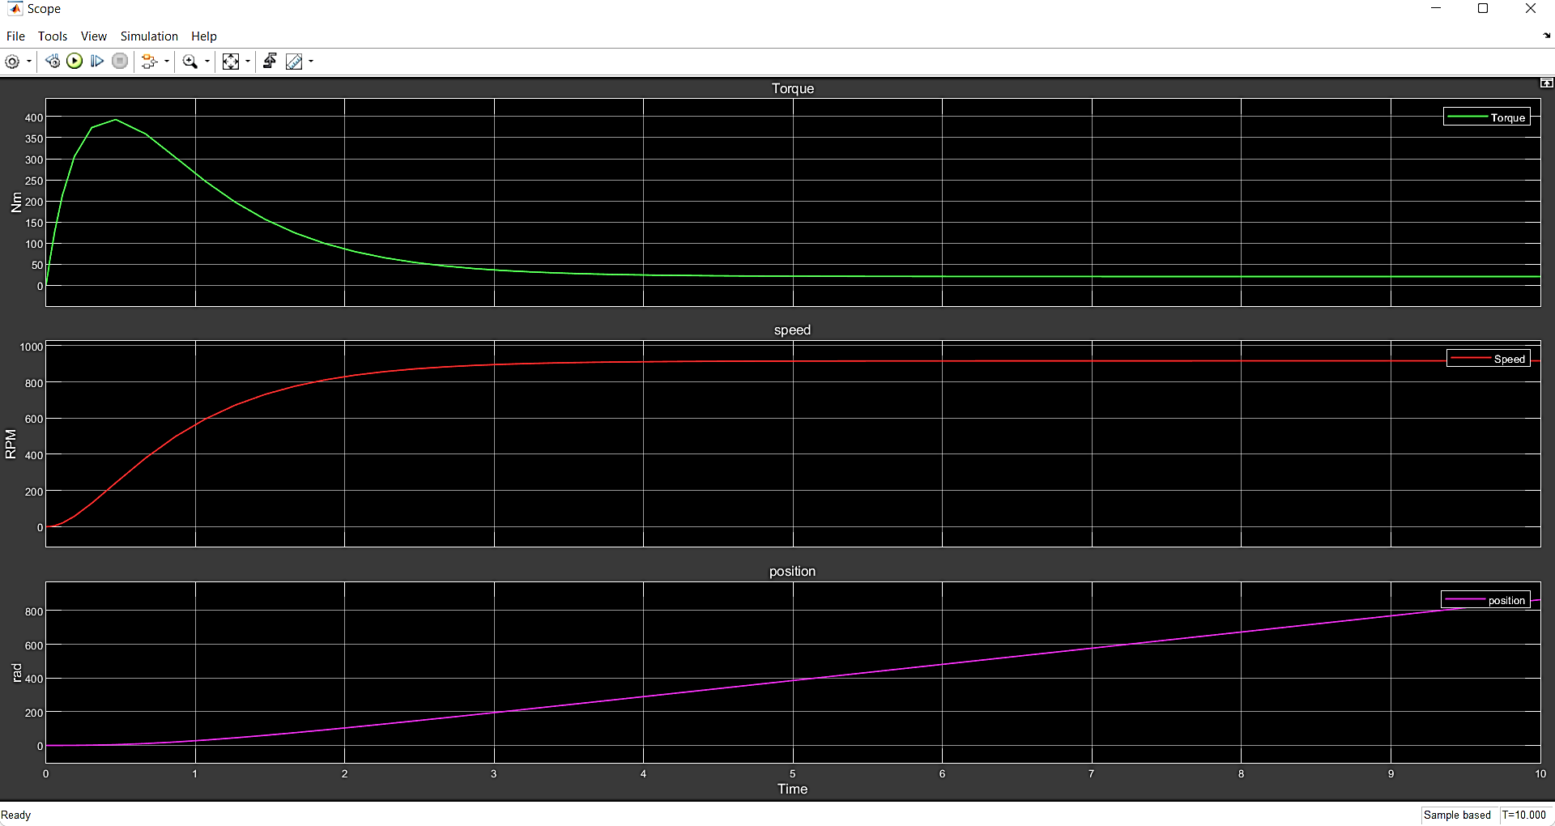

Fig. 4.3 (i) Torque-time specification (ii) Speed-time specification (iii) Position-time specification

On simulating the model in MATLAB, the Torque-time and Speed-time graphs were obtained as shown in Fig. 4.3 (i) and Fig. 4.3 (ii).

**4.2 Closed Loop speed control of a PMDC motor**

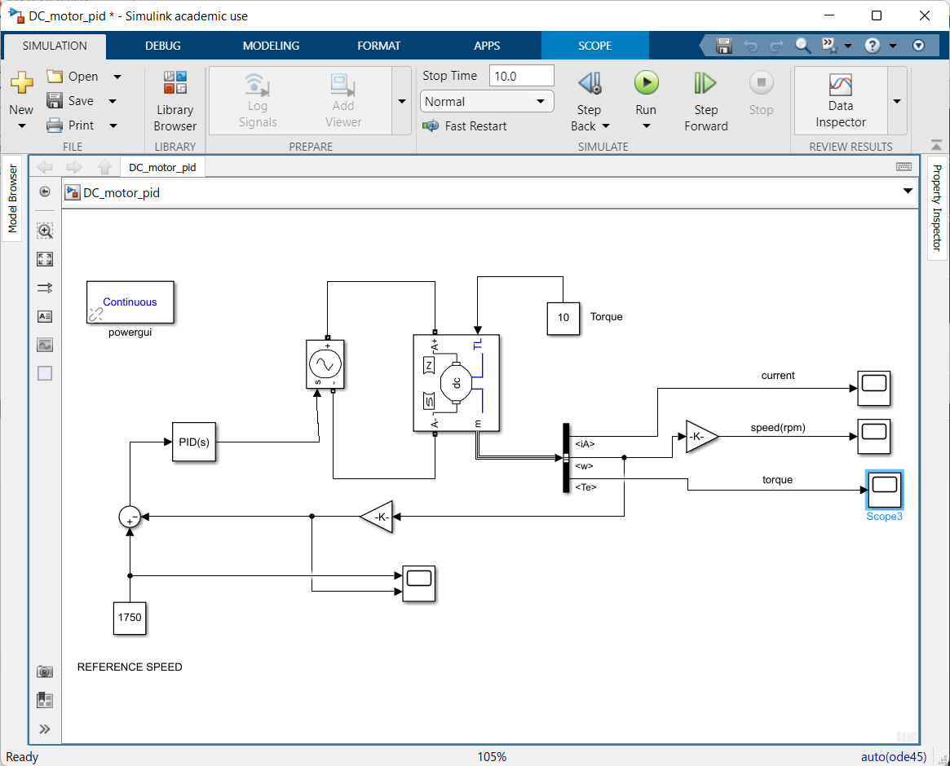

Fig. 4.4 Closed loop speed control of a PMDC motor

The above Fig 4.6 shows the closed loop control system of the motor with motor parameters listed in Table. 4.1. Since Open Loop systems cannot be tuned at will for desired rise time and settling time, we go for the closed loop control system of the model. In the closed loop control system model, a PID controller is used for controlling the Controlled Voltage source block in-order to control the voltage supplied to the armature of the PMDC motor, by providing the error signal to it.

Now the PID controller is tuned using the internal app of the MATLAB to meet the requirement of 0.1s rise time and settling time less than 0.5s.

The tuned PID values can be found in Fig. 4.6 and the tuned and untuned response of the plant can be found in Fig. 4.7.

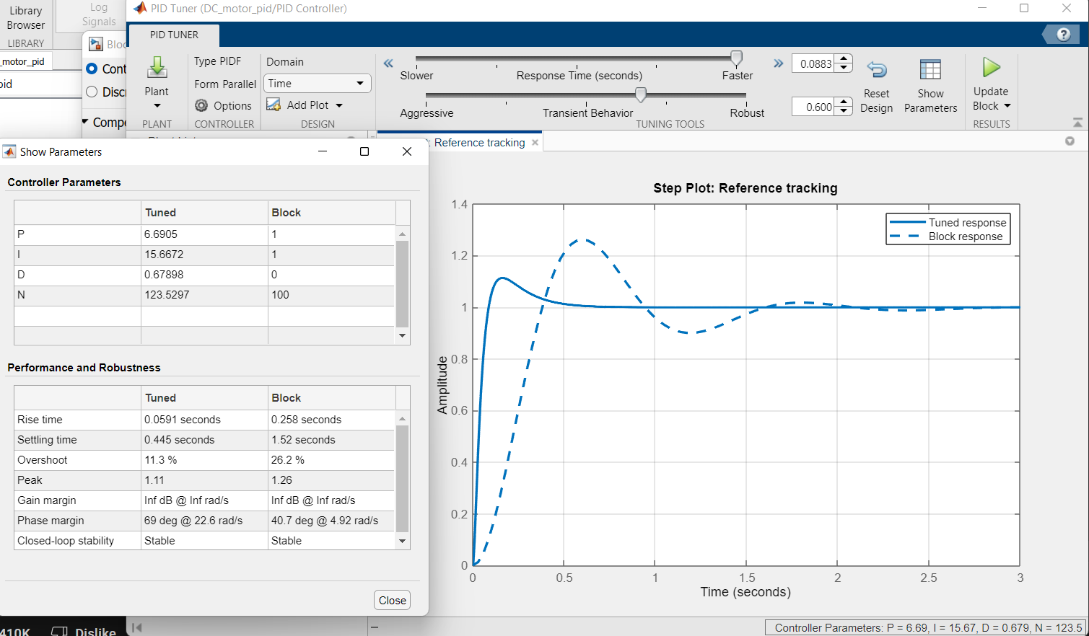

Fig. 4.5 PID tuning using internal app

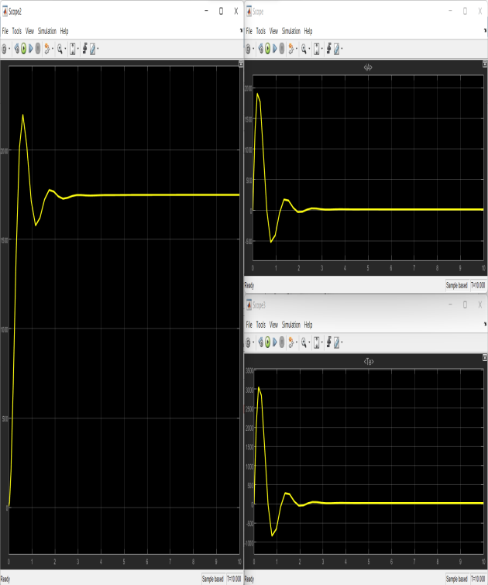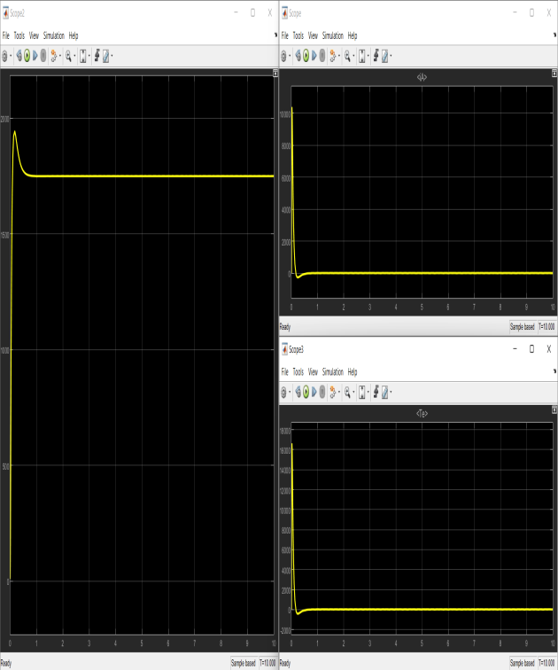

**Untuned response Tuned response**

Fig. 4.6 Comparison between tuned and untuned responses of the model

**4.3. LINEAR ACTUATOR CONTROL:**

In order to climb a step, the proposed device must have linear actuators that extend and retract while balancing the load of the person seated. Such Actuators must not only be able to bear the load of the person but also provide non jerky motion.

A linear actuator is modeled as a simple Lead-Screw mechanism using Simscape block in Simulink. The motion of the Lead-Screw block is controlled using a PMDC motor, whose speed is controlled using Armature current control technique.

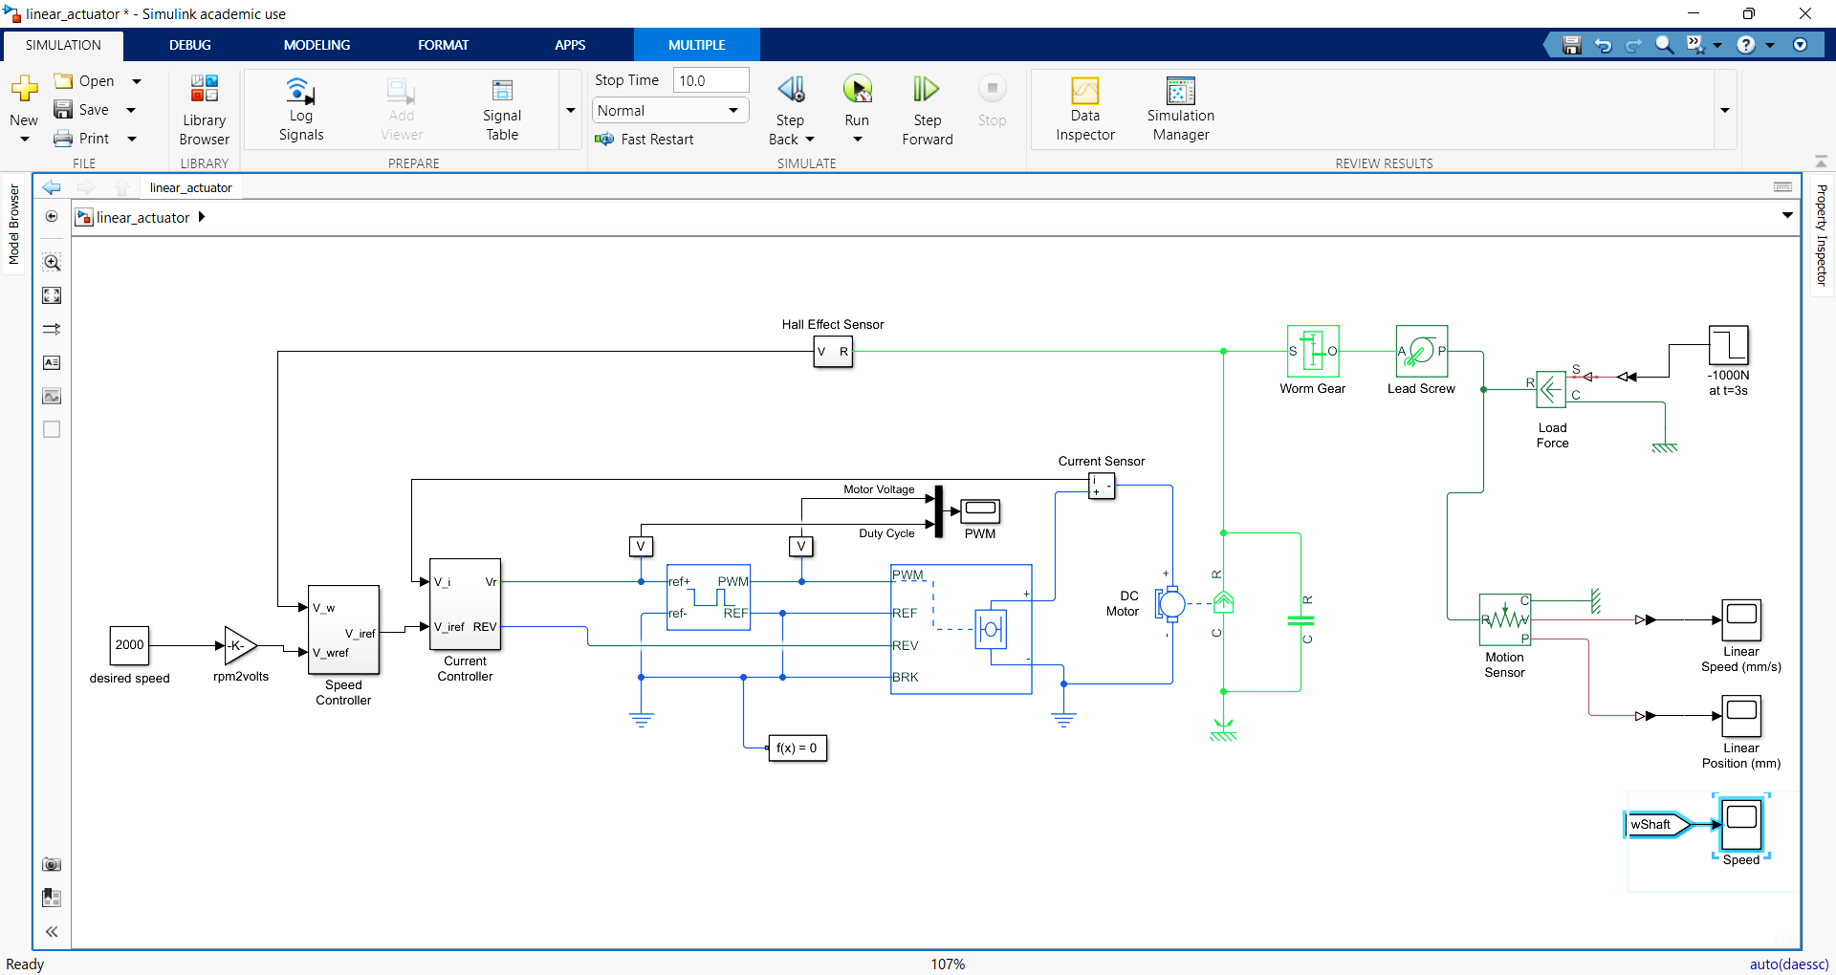

Fig. 4.7 Closed loop control system for linear actuator

The mechanical and electrical components of the actuator model is designed using Simscape Electrical and Simulink block sets. The Linear Actuator control model consists of two cascaded control feedback loops for controlling the armature current and angular speed.

A load of 100 kg is put on the linear actuator at time 3s.

**4.3.1 Speed controller sub system**

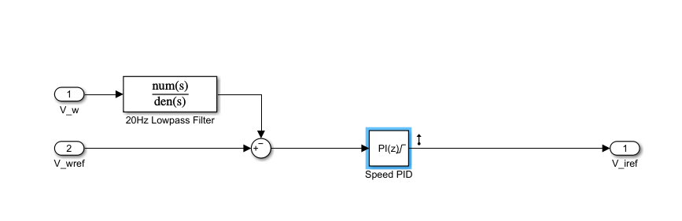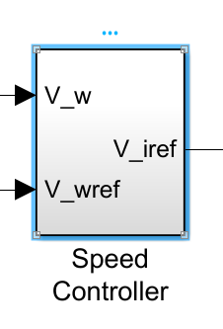

Fig. 4.8 speed controller subsystem

The Speed control sub system makes the outer feedback loop that uses a PI controller to control the speed of the PMDC motor in order to achieve constant linear velocity of the Lead-Screw mechanism. A Hall effect sensor is placed in the feedback loop to sense the angular speed of the motor shaft and convert it into voltage signal, to be fed back to the PI controller. A Low pass filter is used to attenuate any high frequency noise picked up by the Hall effect sensor present in the feedback loop.

This results in the introduction of lag during the speed tracking of the shaft by the Hall-effect sensor.

**4.3.2 Current controller sub system**

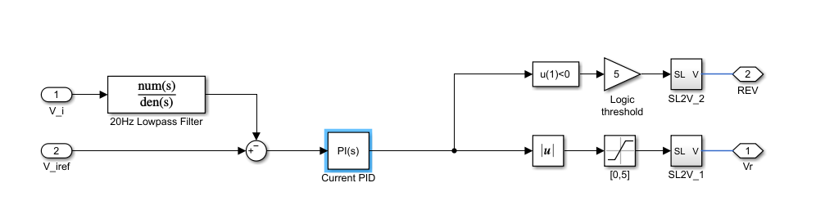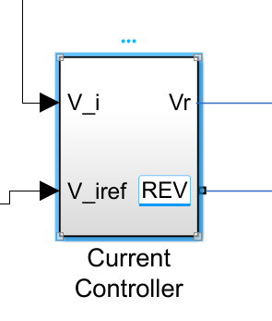

Fig. 4.9 Current controller sub system

The Current control sub system makes the inner feedback loop that uses a PI controller to control the armature current of the PMDC motor in order to achieve constant linear velocity of the Lead-Screw mechanism. A Current sensor is placed in the feedback loop to sense the armature current and using a low pass filter high frequency noise are attenuated and fed back to the current PI controller. The output of the current control subsystem is provided as the input for the PWM (Pulse Width Modulation) block in order to switch on and off the armature current, thus controlling the speed of the motor. The output from the current PI controller is checked for its sign and saturated to 5 V.

In order to reverse the motor drive direction, a Hex-Bridge block is used and based on the output value of the current control subsystem, the motor drive direction is changed.

Thus, ensuring Extension and Retraction of the linear actuator.

**4.3.3 Tuning of the cascaded controllers**

The pant should be linerized and tuned to achieve the following requirements

Table. 4.2 Tuning requirements

|  |  |  |
| --- | --- | --- |
| **S.no.** | **Requirements** | **Desired values** |
| **1.** | Rise time | 0.1s |
| **2.** | Settling time | Less than 0.5s |
| **3.** | % Steady state error | 10% or less |

The Speed and current control block are tuned using the control system tuner app usingreference tracking goal and the step response of the tuned model is shown in Fig. 4.10, Fig. 4.11 and Fig 4.12s

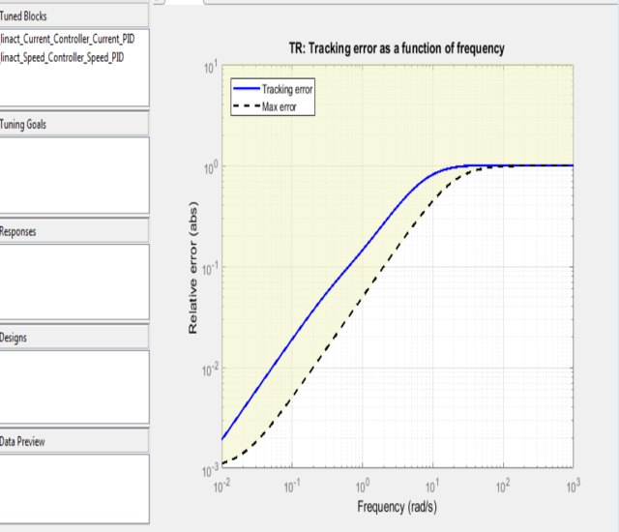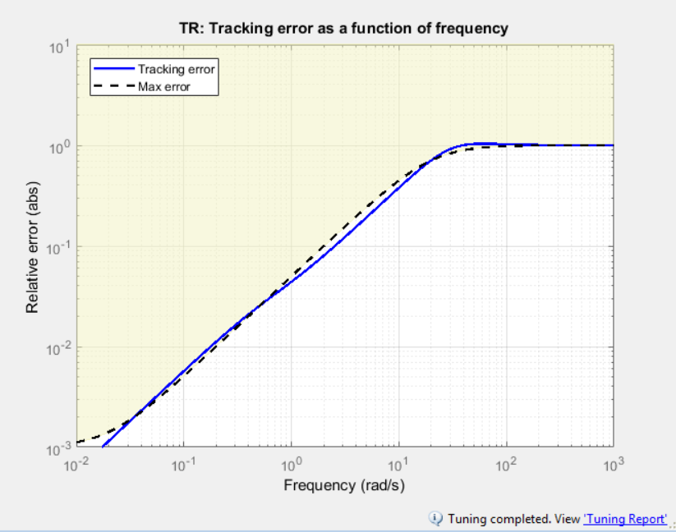

Fig. 4.10 Tracking error Vs Frequency

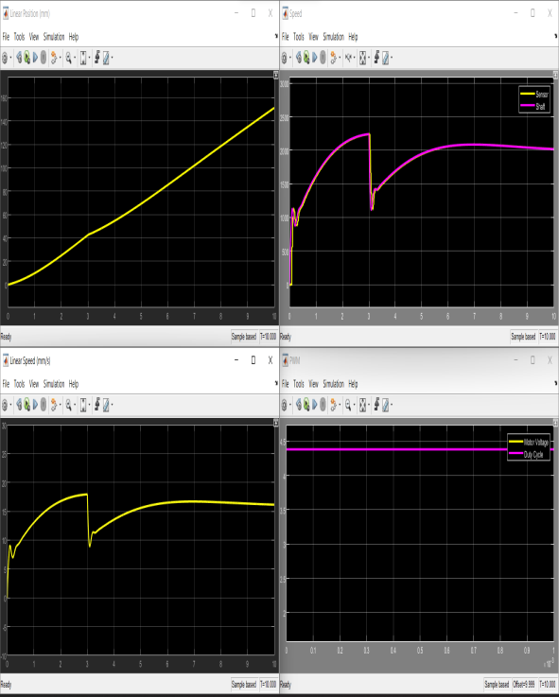

Fig. 4.11 Untuned response of the model

i.Linear position (mm) Vs time (s) ii. Angular velocity (rpm) Vs time (s)

iii. Linear velocity (mm/s) Vs time (s) iv. PWM (V) Vs time(s)

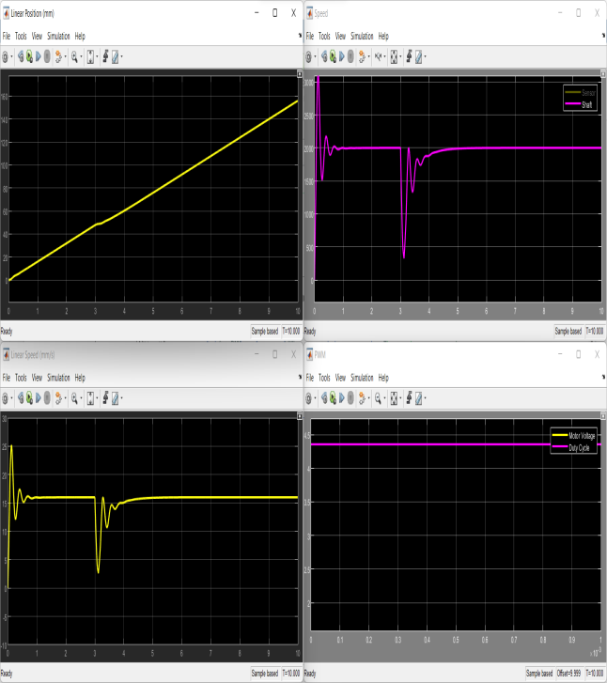

Fig. 4.11 Tuned response of the model

i.Linear position (mm) Vs time (s) ii. Angular velocity (rpm) Vs time (s)

iii. Linear velocity (mm/s) Vs time (s) iv. PWM (V) Vs time(s)

**PI values after tuning the plant using Control system Tuner App in MATLAB**

On tuning for diffferent Loads, the PI constants obtained are listed in Table. 4.3,4.4,4.5.

Table. 4.3 PI value for 50kg load

|  |  |  |
| --- | --- | --- |
| **S.No.** | **Speed PI** | **Current PI** |
| **1.** | P = 1.00431 | P = 1.00756 |
| **2.** | I = 2.00908 | I = 30.083 |

Table. 4.4 PI value for 100kg load

|  |  |  |
| --- | --- | --- |
| **S.No.** | **Speed PI** | **Current PI** |
| **1.** | P = 0.75565 | P = 2.99980 |
| **2.** | I = 5.00342 | I = 50.10324 |

Table. 4.5 PI value for 150kg load

|  |  |  |
| --- | --- | --- |
| **S.No.** | **Speed PI** | **Current PI** |
| **1.** | P = 0.69073 | P = 3.5659 |
| **2.** | I = 5.50856 | I = 60.0778 |

**4.4. Designof Step climbing Wheelchair:**

After creating the control system we attained the speed control of the DC motor. Now our ultimate aim is to create and analyze the wheelchair model. For this, we designed a wheelchair in the SOLIDWORKS software. The wheelchair consists of 6 wheels that are capable of moving up and down. The next ultimate goal is to transfer people by themselves without the help of others. For that, we designed the self-transfer vehicle which is attached to the wheelchair. The wheels will move to and fro with the help of a PMDC motor attached to the wheels, whose speed will be controlled by the PID controller**.**

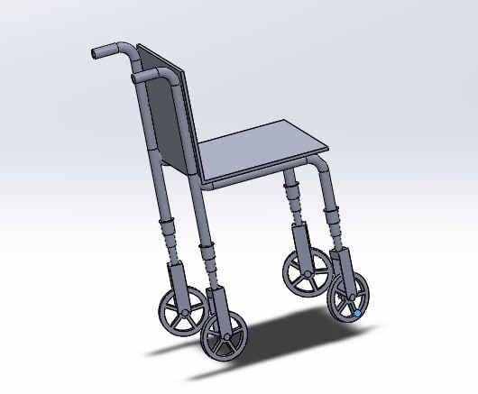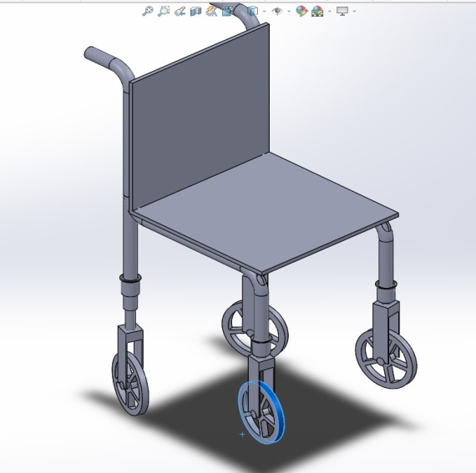

Fig. 4.13 Wheelchair design

Fig. 4.13 is the wheelchair that can entrain and detrain the train by the up and down motion of the wheels with the help of a telescopic mechanism. The telescope mechanism is designed in the SOLIDWORKS software and it is attached between the frame and the wheel.

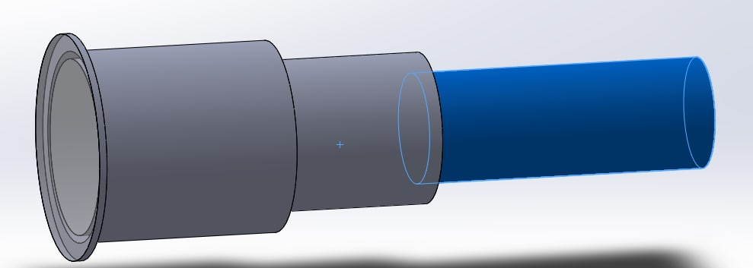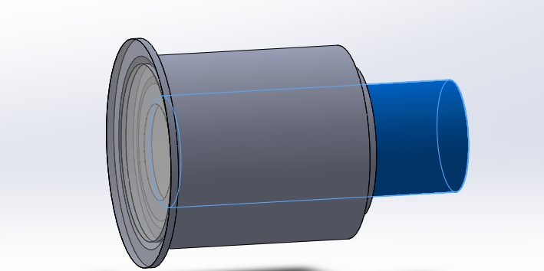

Fig. 4.14 Telescope mechanism in extended Fig. 4.15 Telescope mechanism in retracted

position position

In Fig. 4.14 the telescope mechanism is in the extended position and in Fig. 4.15 the telescope mechanism is in the retracted position.

**4.5. PROCESS:**

After designing the wheelchair along with the self-transfer vehicle, it is converted into .STL file and it is imported to the CoppeliaSim software. In CoppeliaSim software, we given all joint configuration and hierarchy. The hierarchy should be given correctly according to the joints. Then we imported the control systems to the CoppeliaSim software. The control system will control the speed of the motors with the PID controller.

**4.6. MECHANISM:**

The motors are connected to the 6 wheels and the 6 telescopes through the joint configuration. Motors attached to the wheels will help them to move to and fro and motors attached to the telescope will help the wheels to move up and down for entraining and detraining from the train. In Fig. xx initially, all six wheels will be on the ground and it will be moving. When it reaches the staircase of the train, first the front two wheels will move upward with the help of a telescopic mechanism and the other wheels move forward. Once the front wheels landed, the middle wheels move upward and the other wheels move forward. Atlast when both the front wheels and middle wheels are landed, the last row of wheels will move upward and others move forward. After all these mechanisms, the wheelchair will be entrained into the train. In the telescopic mechanism, initially the telescopic will be in the extended position. In order to move the wheel upward, the telescope will retract, and to move the wheel down the telescope will extend.

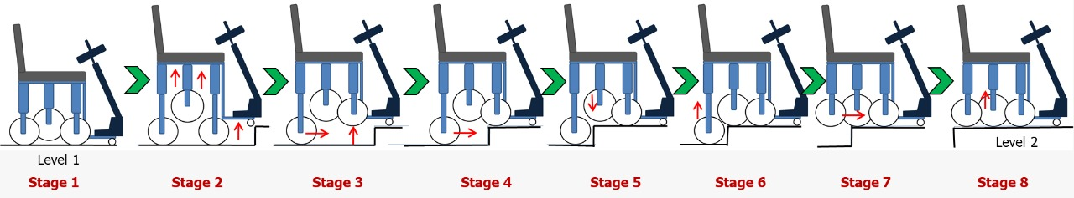

Fig. 4.16 Entraining and detraining mechanism

**CHAPTER 5**

**RESULT AND DISCUSSION**

**5.1 Result:**

The designed Motor drive control system yields the desired rise time of 0.1s, settling time of less than 0.5s for the Motor drive successfully.

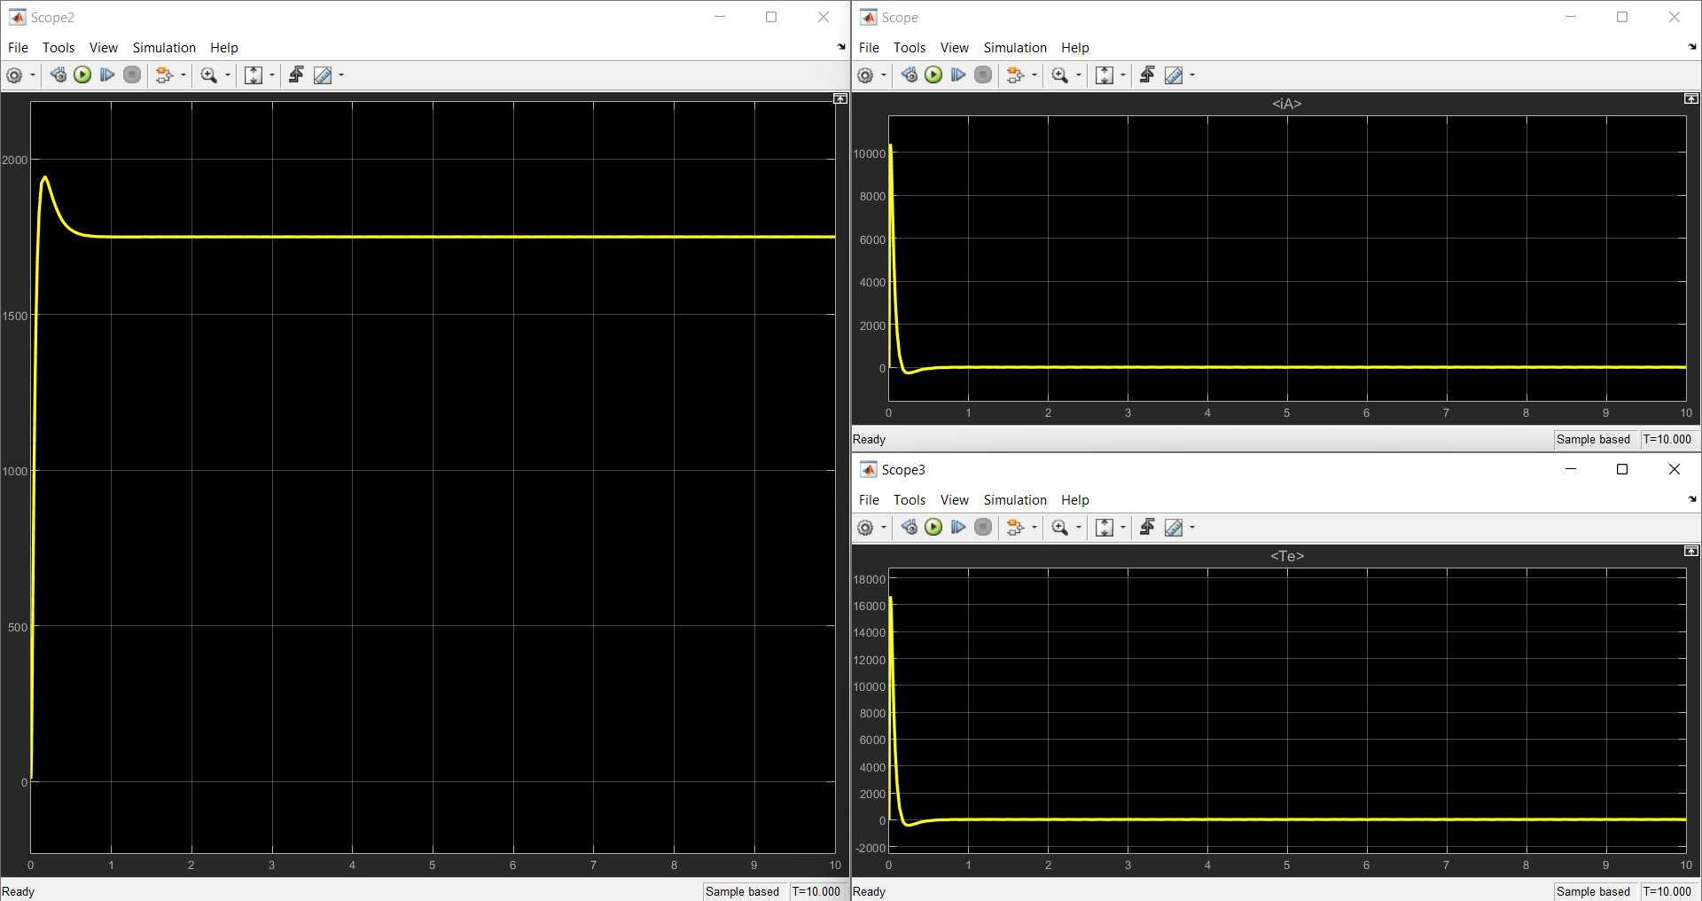

Fig. 5.1Simulation result of closed loop control of Motor drive

The designed Linear actuator control system yields the desired rise time of 0.1s, settling time of less than 0.5s, less than 10% steady state error has been achieved for different Load factors for the Linear actuator successfully.

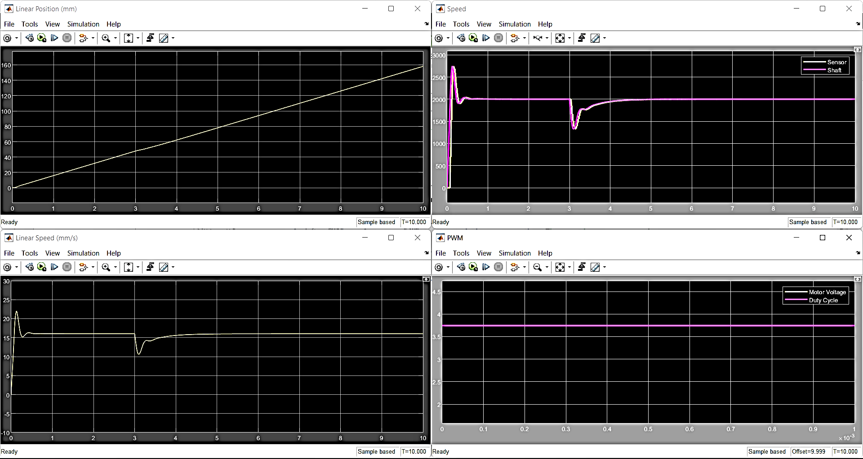

Fig. 5.2Simulation result from closed loop control of linear actuator

**5.2Discussion:**

The URDF and Mesh model imported from SOLIDWORKS into the CoppeliaSim environment was highly unstable although, the Joint-Link Hierarchy and Joint, Link dynamic properties were properly configured.

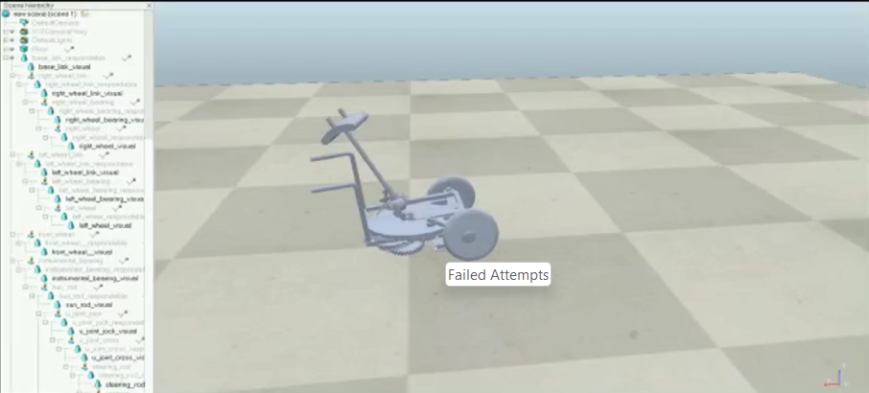

Fig. 5.3. Failed Attempts

**CHAPTER 6**

**REFERENCES**

1. Design of Wheelchair in SOLIDWORKS :

<https://youtu.be/hojGPuofdBM>

1. Control of Linear actuator:

<https://in.mathworks.com/help/physmod/sps/ug/linear-electric-actuator-motor-model.html>

1. Telescope mechanism:<https://youtu.be/7TAO8rGbVtU>
2. PID Controller and design:<https://youtu.be/iS5JFuopQsA>
3. Morales, R., Gonzalez, A., Feliu, V. *et al.* Environment adaptation of a new staircase-climbing wheelchair. *Auton Robot* **23,**275–292 (2007). <https://doi.org/10.1007/s10514-007-9047-6>
4. D. Delgado-Mena, E. Pereira, C. Alén-Cordero, S. Maldonado-Bascón and P. Gil-Jiménez, "Control architecture for a novel Leg-Based Stair-Climbing Wheelchair," 2021 European Conference on Mobile Robots (ECMR), 2021, pp. 1-6, doi: 10.1109/ECMR50962.2021.9568794.

<https://ieeexplore.ieee.org/stamp/stamp.jsp?tp=&arnumber=9568794&isnumber=9568783>

1. Y. Ma and F. Lyu, "Design of A Wheel-Legged Stair Climbing Robot," 2021 7th International Conference on Control, Automation and Robotics (ICCAR), 2021, pp. 146-150, doi: 10.1109/ICCAR52225.2021.9463485.

<https://ieeexplore.ieee.org/stamp/stamp.jsp?tp=&arnumber=9463485&isnumber=9463319>

1. N. Shashank Shivakumar, V. Shreyaas Viishvak, R. B. K. Ashok and R. Hari Krishnan, "Development of a Mechanism to Dock a Robotic Self-Transfer Device to a Wheelchair," *2019 IEEE International Conference on System, Computation, Automation and Networking (ICSCAN)*, 2019, pp. 1-5,

doi: 10.1109/ICSCAN.2019.8878755.

<https://doi.org/10.1115/1.4032867>

1. *“Majority of passengers with disabilities report problems using train”,* this article was published before 2 years by *The Guardian Labs.* In this, they given the survey of how many people encounted barriers to travel when using trains.

<http://www.theguardian.com/society/2019/jul/08/majority-passengers-disabilities-report-problems-using-trains-uk>

**PEER EVALUATION FORM FOR GROUP WORK**

Your name: Ambhareesh M D

Write the name of each of your group members in a separate column. For each person, indicate the extent to which you agree with the statement on the left, using a scale of 1-4 (1=strongly disagree; 2=disagree; 3=agree; 4=strongly agree). Total the numbers in each column.

|  |  |  |
| --- | --- | --- |
| Evaluation Criteria | Group Member:  Venkatraman S | Group Member:  Sethu Narayanan |
| Attends group meetings regularly and arrives on time. | 4 | 4 |
| Contributes meaningfully to group discussions. | 4 | 4 |
| Completes group assignments on time. | 4 | 4 |
| Prepares work in a quality manner. | 4 | 4 |
| Demonstrates a cooperative and supportive attitude. | 4 | 4 |
| Contributes significantly to the success of the mini project. | 4 | 4 |
| Total | 24 | 24 |

**Feedback on Team dynamics:**

1. How effectively did your group work?

We worked very effectively without seeing any time constraints with a very great coordination from the start of a project till the end of the project.

1. Were the behaviors of any of your team members particularly valuable or detrimental to the team? Explain.

The behavior of my team members is valuable to a greater extent as they are the important pillars in reducing the errors and improvising the project output.

1. What did you learn about working in a group from this mini project that you will

carry into your next group experience?

I learnt about teamwork can improve effectiveness of the project, by the sharing the perspectives and general knowledge and group coordination is improved.

**Self-Evaluation Form for Group Work**

Your name: Ambhareesh M D

|  |  |  |  |
| --- | --- | --- | --- |
|  | Seldom | Sometimes | Often |
| Contributed good ideas |  |  | ✓ |
| Listening to and respected the ideas of others |  |  | ✓ |
| Compromised and cooperated |  |  | ✓ |
| Took initiative where needed |  |  | ✓ |
| Came to meetings prepared |  |  | ✓ |
| Communicated effectively with teammates |  |  | ✓ |
| Did my share of the work |  |  | ✓ |

My greatest strengths as a team member are:

* I can listen to the team members views about a topic patiently.
* I can extend my hands for support for the fellow team member if they need any help in their work.

The group work skills I plan to work to improve are:

* To improve my views over analyzation.

**PEER EVALUATION FORM FOR GROUP WORK**

Your name: Venkatraman S

Write the name of each of your group members in a separate column. For each person, indicate the extent to which you agree with the statement on the left, using a scale of 1-4 (1=strongly disagree; 2=disagree; 3=agree; 4=strongly agree). Total the numbers in each column.

|  |  |  |
| --- | --- | --- |
| Evaluation Criteria | Group Member:  Ambhareesh M D | Group Member:  Sethunarayanan S |
| Attends group meetings regularly and arrives on time. | 4 | 4 |
| Contributes meaningfully to group discussions. | 4 | 4 |
| Completes group assignments on time. | 4 | 4 |
| Prepares work in a quality manner. | 4 | 4 |
| Demonstrates a cooperative and supportive attitude. | 4 | 4 |
| Contributes significantly to the success of the mini project. | 4 | 4 |
| Total | 24 | 24 |

**Feedback on Team dynamics:**

1. How effectively did your group work?

My group worked very effectively during the project right from the beginning till the end report submission.

2. Were the behaviors of any of your team members particularly valuable or detrimental to the team? Explain.

No, the behavior of each of our team members did not become detrimental to the

team instead their attitude towards the work became very valuable to the team in

completing the work ahead of the deadlines.

3. What did you learn about working in a group from this mini project that you will

carry into your next group experience?

My learning outcomes after working in a group are:

• Feedback on performance.

• To plan and manage time.

• Responsibilities.

• Sharing Perspectives.

**Self-Evaluation Form for Group Work**

Your name: Venkatraman S

|  |  |  |  |
| --- | --- | --- | --- |
|  | Seldom | Sometimes | Often |
| Contributed good ideas |  |  | ✓ |
| Listening to and respected the ideas of others |  |  | ✓ |
| Compromised and cooperated |  |  | ✓ |
| Took initiative where needed |  |  | ✓ |
| Came to meetings prepared |  |  | ✓ |
| Communicated effectively with teammates |  |  | ✓ |
| Did my share of the work |  |  | ✓ |

My greatest strengths as a team member are:

* Providing support and cooperation to the team members when needed.
* Taking initiative where needed during the work.

The group work skills I plan to work to improve are:

* To establish a shared identity with other group members.
* To refine understanding through more discussions.

**PEER EVALUATION FORM FOR GROUP WORK**

Your name: Sethu Narayanan S

Write the name of each of your group members in a separate column. For each person, indicate the extent to which you agree with the statement on the left, using a scale of 1-4 (1=strongly disagree; 2=disagree; 3=agree; 4=strongly agree). Total the numbers in each column.

|  |  |  |
| --- | --- | --- |
| Evaluation Criteria | Group Member:  Ambhareesh M D | Group Member:  Venkatraman S |
| Attends group meetings regularly and arrives on time. | 4 | 4 |
| Contributes meaningfully to group discussions. | 4 | 4 |
| Completes group assignments on time. | 4 | 4 |
| Prepares work in a quality manner. | 4 | 4 |
| Demonstrates a cooperative and supportive attitude. | 4 | 4 |
| Contributes significantly to the success of the mini project. | 4 | 4 |
| Total | 24 | 24 |

**Feedback on Team dynamics:**

1. How effectively did your group work?

My group performed the work very greatly from the start to end of the project.

2. Were the behaviors of any of your team members particularly valuable or detrimental to the team? Explain.

The behavior of each of my team members is very valuable without their

cooperation the project cannot be completed as per scheduled time.

3. What did you learn about working in a group from this mini project that you will

carry into your next group experience?

I learnt about teamwork can improve effectiveness of the project, and how the

sharing the perspectives of every team member improves the effectiveness of the project.

**Self-Evaluation Form for Group Work**

Your name: Sethu Narayanan S

|  |  |  |  |
| --- | --- | --- | --- |
|  | Seldom | Sometimes | Often |
| Contributed good ideas |  |  | ✓ |
| Listening to and respected the ideas of others |  |  | ✓ |
| Compromised and cooperated |  |  | ✓ |
| Took initiative where needed |  |  | ✓ |
| Came to meetings prepared |  |  | ✓ |
| Communicated effectively with teammates |  |  | ✓ |
| Did my share of the work |  |  | ✓ |

My greatest strengths as a team member are:

* I can listen to the team members views about a topic patiently.
* I can offer the support for the fellow team member if they need any help in their

work.

The group work skills I plan to work to improve are:

* To improve my communication in seminars.
* To encourage teammates more to get the desired result.